

COMPUTER SCIENCE PRACTICE

4COSC008C

Political Activism Through Social Media Data Mining for The Election Campaign

Data Mining and Social Media: how are our political opinions affected by the use of data mining by social networks? What are the ethical and/or legal implications?

Module Leader’s Name – Ms. Sulochana Rupasinghe

Tharindu Niroshan Andrew De Silva

UoW ID - W1761890

Student ID - 2018367

Group Members

Tharindu Niroshan De Silva - w1761890

Manodya Mendis - w1761956

Hakeem Fazli - w1761372

Osanda Ginige - w1761754

Ashen Induwara - w1761741

Contents

List of Figures 2

Abstract 3

Introduction 4

Literature Review 5

Methodology 7

Results and Discussion 8

Results 8

Discussion 9

Conclusion 10

References 11

Work Breakdown Structure 12

UoW NO:1761890

# List of Figures

Obama and McCain Online Activity a 8

Obama and Romney Online Activity a 8

Disabled fake accounts by Facebook a 8

UoW NO:1761890

UoW NO:1761890

# Abstract

Social media is becoming a core strategy for political campaigns in the modern world. Social media has become a part of people everyday life. News that are being shared through the social media, discussion about the prevailing issues in the country, personal perspectives can be use as source of information to be identifying each users’ opinions. This information can use for the political campaigns to improve their process as feedbacks. Not only that but also those data can be used for different activities related to political activism. This research report is based on data mining in social media and how it has been used in history and issues that are facing through this process. Also, future of the data mining in social media for the election campaign, will it be succeeded or fail and what are the new implications.

UoW NO:1761890

# Introduction

Data mining is extracting large data sets to identify the patterns and set relationships among data to solve problems through the data analysis. Data mining in social media is using social media as the data source for data extraction. Data mining process can define basically as data gathering, data sorting then drawing conclusions.

In this topic, political activism through the data mining in social media for the election campaign will be covered. Political parties use data mine in social media for to maintain their campaign process. Using analyzed data, it can show the current position in the election campaign race with other competitors and help to improve the campaign process to achieve the best outcome at the elections. There can be false information in the social media so it can be affected to the data mining process and for the results. During past few years most of the election campaign have used data mining using social media only for getting future prediction. But in 2016 trump campaign has done a massive impact in data mining using social media to optimize their election campaign. According to previous researches all the future predictions has been true with a minimum of 60% accurate. Most of the data mine has used Facebook as the social media source. But with the growth of the technology and the number of user and lot of data shared within social media has brought data mine process to a next level.So, for the future data mine in social media for the election campaign analysis can give more accurate predictions? Because number of users are increasing, also fake news and fake profiles are being creating. So, can we procced the data mining in social media for the election campaign or will it be less efficient? What are the best methods that are used by different election campaign to succeed their goal in the history which used data mining techniques?

UoW NO:1761890

# Literature Review

Election campaign is more important to the political parties in a country. In order to become succeed they must maintain their campaigning process effectively. For that information and feedbacks from the public is very important. The most accurate way of doing that in the modern world is data mining in social media because of the high amount of data and information generating in a period of a time. In past data mining in social media have been used for election campaigns in different countries.

Impact of the social media in politics were first felt when Barack Obama did the online voting during 2008 presidential election using Facebook. According to Kimanchia “This election was dubbed as the “Facebook Election” and finally it shows up the 70% of youth votes”. Also, in 2012 election Obama shows up a higher range of social media response than his competitor.

In 2013 general election in Kenya President Kenyatta started a social media election campaign through Facebook by targeting the youth. According to Kimanchia by the time president Kenyatta’s Facebook page had over more than 0.5 Million ‘likes’ and it’s the one of most likes pages in Africa.

In India during 2014 also has used data mining in social media for the election campaign and by the time his Facebook reached 16 million “likes” and became the sixth most followed leader world leader on twitter.

The most iconic data mining in social media incident is trump campaign in 2016. Trump campaign hired a company called Cambridge Analytica to data mine from social media and use analyzed data for the election campaign purposes with the help of Facebook. Group of Cambridge Analytica made an app called “this is your digital life”. App is introduced as a psychological research tool which will predict the personality type of the user. In the logging process this app ask user to sign in with their Facebook account. Within the process app will ask for certain access like location etc. At the end with the help of the app it will access to all the data from the Facebook user and also some of details on their friends.

With the help of the mined data Cambridge Analytica will finally able to analysis and set micro-targeted ads for through Facebook to identify voters’ behaviors. Throughout using micro- targeted ads were effectively impacted to change the user’s opinions by changing their political view. Also, those gathered data were included the prevailing problems that have discussed within social media by users. Because people use social media to discuss public topics among the users by creating Facebook groups.

UoW NO:1761890

So, Cambridge Analytica helped the trump campaign by giving advices to make strategic communication with voters in the public speeches such as topics to discuss in speeches and where to stop.

In the Obamas voting scenario in 2008 data mining in social media is limited because of the low amount of the users and people are not using social media to share everything. Nowadays Facebook has 2.3 billion monthly users and 1.5 billion daily active users. So, in Trump campaign in 2016 Cambridge Analytica has shared 70.6 million US Facebook profiles through the process. However, there’s no confirmations that have mentioned whether those data were 100% accurate correct because people share fake news and create fake profiles for their purposes. Predictions can be invalid.

UoW NO:1761890

# Methodology

Throughout the studies it showed that data mining in social media is doing a very supportive role in the election campaign process. From the internet that all the details are based on an incident. So, to go with case study method for this research can be more suitable. First gathering the information from the research papers, websites, blogs etc. Researches that are available for free are very limited in the internet. However, ResearchGate website helped a lot when referring to previously done researches. For data mining thee should be an average usage amount of social media users. Not only data mining researches but also, I was able to refer about the reports and articles from the internet about the statistics of the social media users. Then analyzing what happened in the case and what are methods that are used within process be able to find out the existing problems and new ideas that are not previously mentioned in researches.

UoW NO:1761890

# Results and Discussion

## Results

* In both 2008 and 2012 Obama won the election so possibility of the future predictions is accurate.

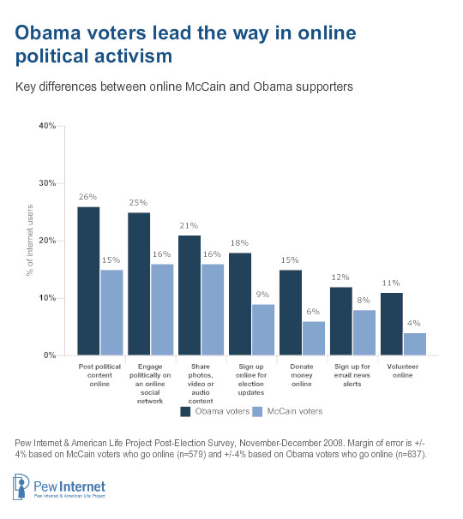

Obama and McCain Online Activity a

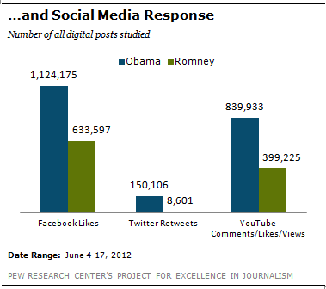

Obama and Romney Online Activity a

* Fake data inside social media can make data mining process less efficient. To avoid that many of social media companies are working on the process of disabling fake profiles and fake news that are spreading through.

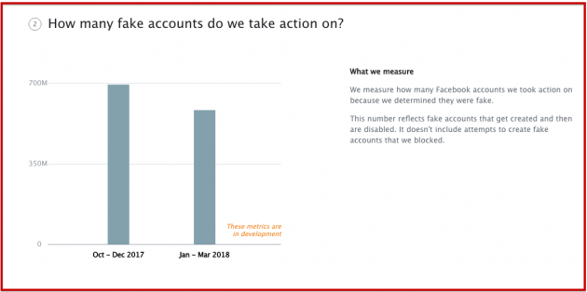

Disabled fake accounts by Facebook a

* Also, data mining companies has started to focus on twitter ‘#’ also known as twitter trends which can easily sort to get peoples opinion about political parties during elections.
* Advertising through the YouTube is more effective because of the incensement of the usage in present.

UoW NO:1761890

## Discussion

* Data mining in social media for the election campaign has been used many times in the history. It has done a great supportive work for the political parties to maintain their campaign process effectively.
* Data in the social media cannot guarantee whether its 100% correct. But previous researches have shown that the results are accurate.
* Both in Obamas and president Kenyatta’s election campaign got the future prediction of the results. But in trump campaign in 2016 it was a little different because they have changed the political view of the users, so they be able to gain more voters on their political side. For the future election campaigns if using data mining in social media changing people political view and the opinion can be more important rather than getting only a future prediction.
* As previously mentioned, researches most used social media was Facebook for the data mine process. But in present according to global social media research summary 2019 other than Facebook, snapchat, YouTube, Instagram has shown a high growth of user activity status. So now it has opened a wide range for data miners to gain data which can be use for future election campaigns. Reason is nowadays people share everything on social media their political view, feedbacks about the current issues, suggestions etc. Political parties can use those data to get more closer to the voters conveniently.

UoW NO:1761890

UoW NO:1761890

# Conclusion

Main key points of this research report

* Political parties can use data from social media to reach their targets in the election campaign.
* Within this process both users and political parties are getting involved so the responsibilities should carry out by both.
* Protecting private data and allowing data access to the companies are users responsibilities.
* Data mining in social media for election campaign cannot be 100% accurate.
* Data miners can get more data from social media because usage has grown up by the time.

Methods and techniques are different from country to country. So further research and recommendations researching about the election campaigns that are using data mining in social media around the world can used to analysis and find out the most effective way of continuing this for the future.

UoW NO:1761890

# References

* Joseph, S., Letsholo, K. and Hlomani, H. (2016). Social Media Data Mining: An Analysis & Overview of Social Media Networks and Political Landscape. *International Journal of Database Theory and Application*, 9(7), pp.291-296
* Gross, T. (2019). *Whistleblower Explains How Cambridge Analytica Helped Fuel U.S. &#039;Insurgency&#039;*. [online] Capeandislands.org. Available at: https://www.capeandislands.org/post/whistleblower-explains-how-cambridge-analytica-helped-fuel-us-insurgency#stream/0 [Accessed 18 Nov. 2019].
* Digital.hbs.edu. (2019). *Politics in India: The Social Media Elections – Technology and Operations Management*. [online] Available at: https://digital.hbs.edu/platform-rctom/submission/politics-in-india-the-social-media-elections/ [Accessed 19 Nov. 2019].
* Medium. (2019). *Effect of Cambridge Analytica’s Facebook ads on the 2016 US Presidential Election*. [online] Available at: https://towardsdatascience.com/effect-of-cambridge-analyticas-facebook-ads-on-the-2016-us-presidential-election-dacb5462155d [Accessed 19 Nov. 2019].
* Sherr, I. (2019). *Facebook, Cambridge Analytica, data mining and Trump: What you need to know*. [online] CNET. Available at: https://www.cnet.com/news/facebook-cambridge-analytica-data-mining-and-trump-what-you-need-to-know/ [Accessed 19 Nov. 2019].
* Graham-Harrison, E. and Cadwalladr, C. (2019). *Revealed: 50 million Facebook profiles harvested for Cambridge Analytica in major data breach*. [online] the Guardian. Available at: https://www.theguardian.com/news/2018/mar/17/cambridge-analytica-facebook-influence-us-election [Accessed 19 Nov. 2019].
* PressAcademia. (2019). *Definition of Case Study*. [online] Available at: https://www.pressacademia.org/definition-of-case-study/ [Accessed 12 Nov. 2019].
* Smart Insights. (2019). *Global social media research summary 2019 | Smart Insights*. [online] Available at: https://www.smartinsights.com/social-media-marketing/social-media-strategy/new-global-social-media-research/ [Accessed 19 Nov. 2019].
* Inc.com. (2019). *Facebook Says It Disabled Almost 1.3 Billion Fake Accounts. (And the Numbers Only Get More Insane From There)*. [online] Available at: https://www.inc.com/bill-murphy-jr/facebook-says-it-disabled-almost-13-billion-fake-accounts-and-numbers-only-get-more-insane-from-there.html [Accessed 17 Nov. 2019].
* Toptal Engineering Blog. (2019). *Data Mining for Predictive Social Network Analysis*. [online] Available at: https://www.toptal.com/data-science/social-network-data-mining-for-predictive-analysis [Accessed 20 Nov. 2019].

UoW NO:1761890

# Work Breakdown Structure